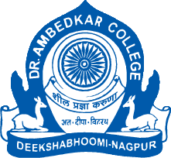
Parampoojya Dr. Babasaheb Smarak Samiti’s
Dr. Ambedkar College, Deekshabhoomi, Nagpur

Joy of Giving Week
Organized by
DEPARTMENT OF LAW
27th September,2022 to 2nd October,2022

Report:
Dr. Ambedkar College, Department of Law, Deekshabhoomi, Nagpur, through its Centre for Constitutional Law and Public Policy Debate in association with Goonj, an NGO had held Joy of Giving Week in the college from 27th September to 2nd October. Goonj is a Delhi based NGO having its offices all over India. The Joy of Giving Week is held throughout India to help Goonj further its philanthropic activities.
The Collection Centre was open for all the citizens of Nagpur from 9 am to 11 am from 27th September to 2nd October. Donations could be given in the form of sarees, school materials, unused papers, woolens clothing, utensils, blankets etc.
Co-ordinator of the Centre for Constitutional Law and Public Policy debate, Dr. Mrs. Varsha Deshpande guided the students to undertake this philanthropic activity. The Principal of the College, Dr. Mrs. B.A. Mehere and the Head of the Department, Dr.Mrs. H.V. Menon gave their valuable support and guidance to the students.
The students of the department and the public at large participated in large numbers. The collected material was then transferred by the volunteers to the Collection Centre at VNIT, Nagpur.
